# **PyCitySchools Analysis**

#Introduction  
The pyschools district is comprised of fifteen high schools that range from small charter schools with less than a thousand students to district schools with almost five thousand students. The total number is 39,170 students in these high schools. The total budget for the district is $24,649,428.00, or an average of $1,643,295 per school or an average of $629.29 per student. The data is for grades nine through twelve. No information about school debt is available. The district has an overall passing rate of 65.17%, this analysis will discuss factors related to student success.



# **School Summary**

The school district has 8 charter schools and 7 district schools. The lowest performing school is Rodriguez High School, with 52.99% of students achieving passing grades in both math and reading. The highest performing school is Cabrera High School, with 91.33% of students passing both math and reading. The highest scores for math are in Pena High School (average math score is 83.82%) and for reading (84.04%) at the same school. Interestingly Penna High School has a slightly lower overall passing rate than Cabrera High School.

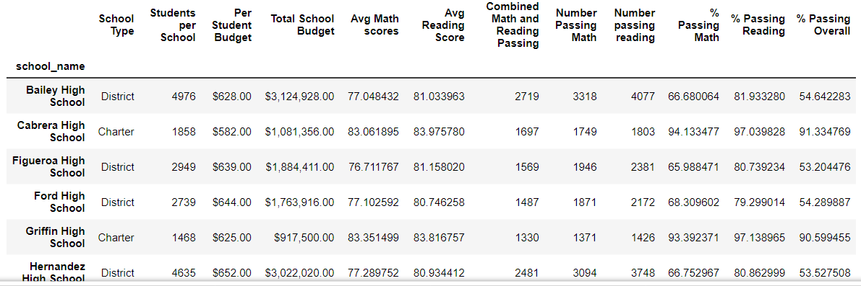

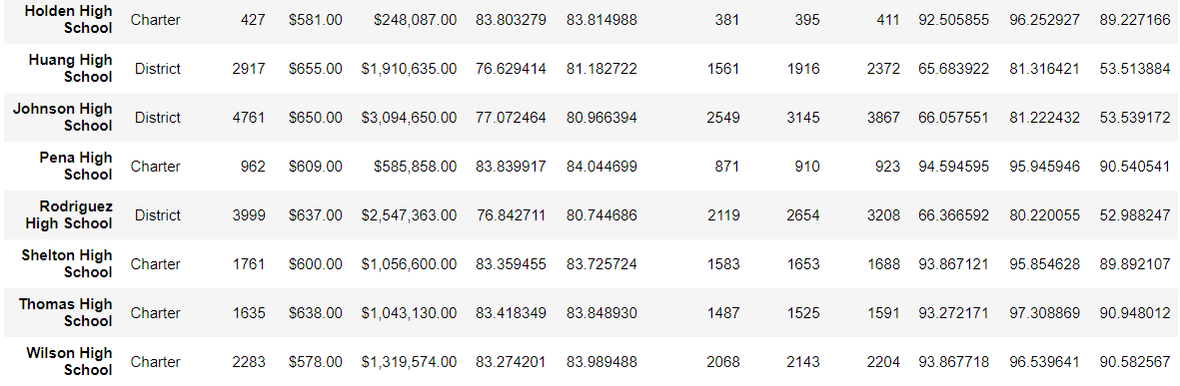

# **Highest Performing Schools (By Overall % Passing)**

Below is the summary data for the top five schools. They are all charter schools, with an average of 1,640 students per school. The average spending per student is $606.40. The average percentage of students passing rate is 90.8%. The average percentage of students passing reading is 96.79% of students, and the percentage of students passing math in these schools is 93.85%.

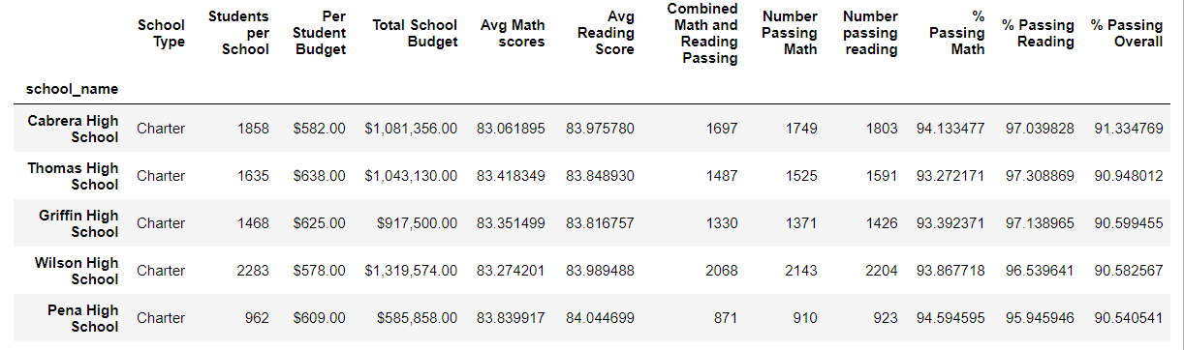

# **Bottom Performing Schools (By Overall % Passing)**

Below is the summary data for the bottom five schools. They are all district schools, with an average of 3,852.2 students per school. The average spending per student is $646.60. The average percentage of students passing rate is 53.35%. The average percentage of students passing reading is 80.87% of students, however, the percentage of students passing math in these schools is 53.35%. The math and overall passing rates are identical, this indicates that the math instruction is likely related to the overall rate of student failure.

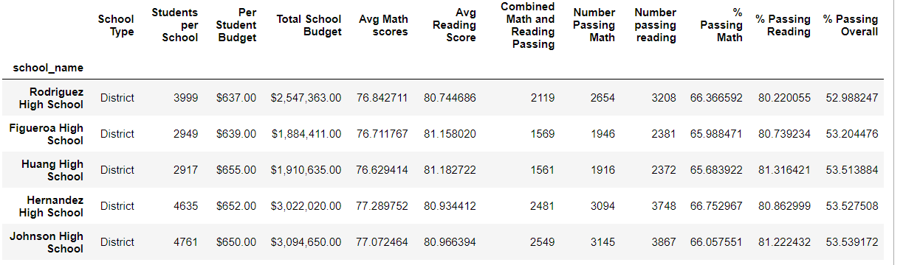

# **Math Scores by Grade**

Below is a table of student math performance by grade level. Analysis of student performance by grade level indicates that the difference in performance starts in the ninth grade. The graph below shows scores for schools graphed out. The graph shows that there is a difference at the 9th grade level (no data from before students started at this school). The graph shows two clusters of lines, one around 77% passing (the district schools) and the other at around 81% passing (the charter schools).

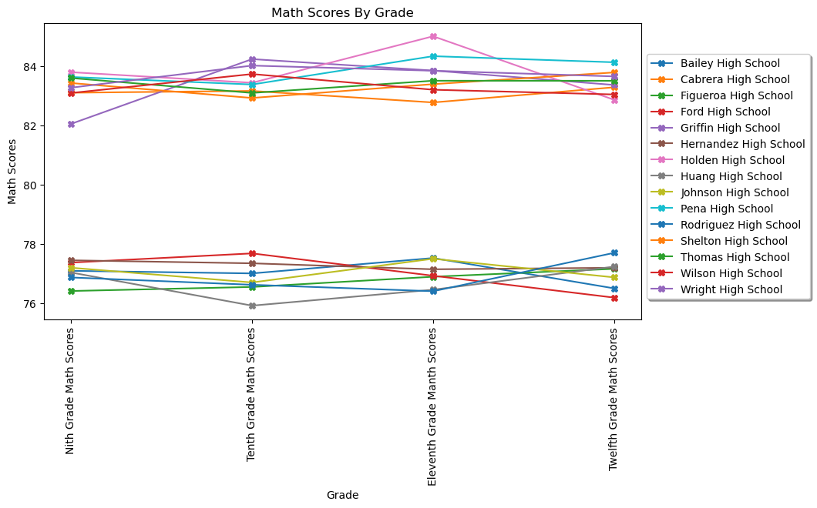

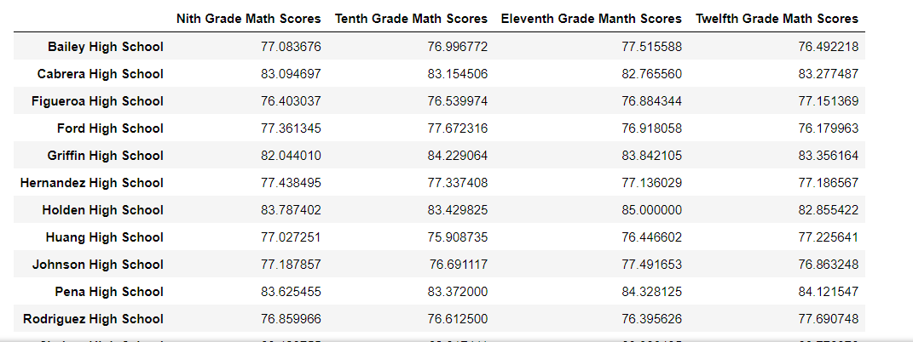

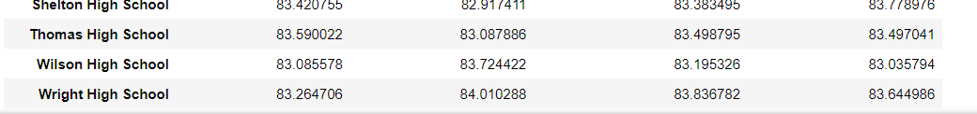

# **Reading Scores by Grade**

Below is a table of student reading performance by grade level. Analysis of student performance by grade level indicates that the difference in performance starts in the ninth grade. The graph below shows scores for schools graphed out. The graph shows that there is a difference at the 9th grade level (no data from before students started at this school). The graph shows two clusters of lines, one around 81% passing (the district schools) and the other at around 84% passing (the charter schools). Although Shelton high school seems to be an outlier in this.

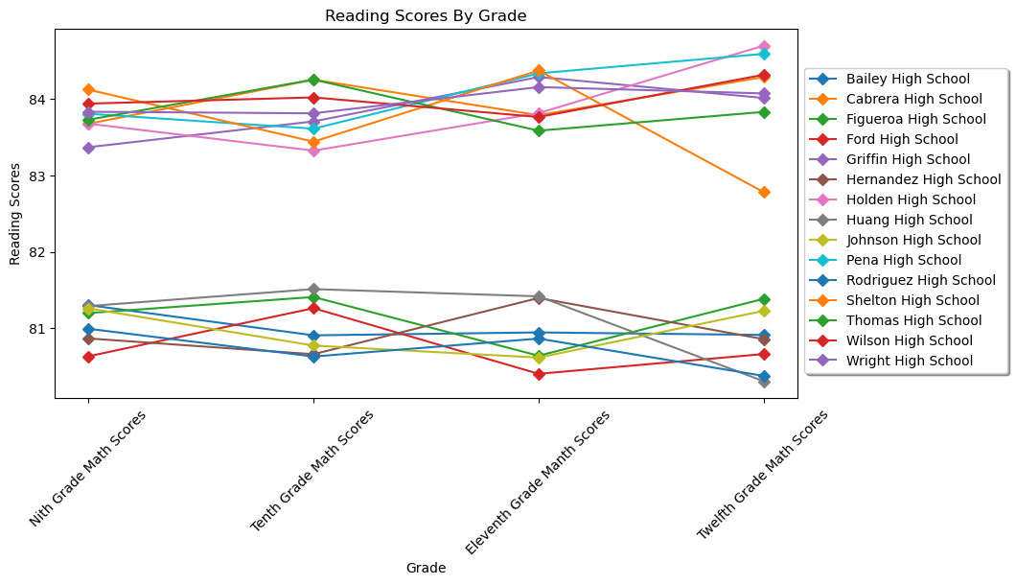

# **Scores By School Spending**

Below is a breakdown of student performance, by total school spending. There is no information on the level of school debt (that would reduce real spending per student), so all numbers are the total spending per student on all costs. The Graph seems to show lower overall passing rates with increased school spending.  
The spending group under $585 has the best results in math passing, reading passing and overall passing. This is seen in both the absolute numbers and more dramatically in the percentage passing.

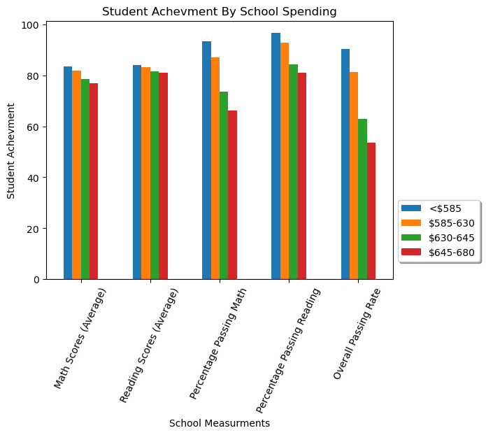

# Scores By School Size

The below has a breakdown of school performance by size. The summary percentages here are rounded.

The graph below shows that the small and medium-sized schools have fairly similar performances. The average reading scores are about 83%, the average math scores are about the same. The percentages of students in the small and medium schools passing math are about 93% and 96% for reading. The overall passing rate is about 90% in both these size ranges.

However, the large schools seem to have slightly worse total numbers, but much worse percentages. For the average math score it is 77.7% and the average reading score is about 81%, the percentages for students passing are 69.96% for math and 82.77% for reading. The overall passing rate is around 58%. It may be that there is a benefit to having teachers with more time for each student.

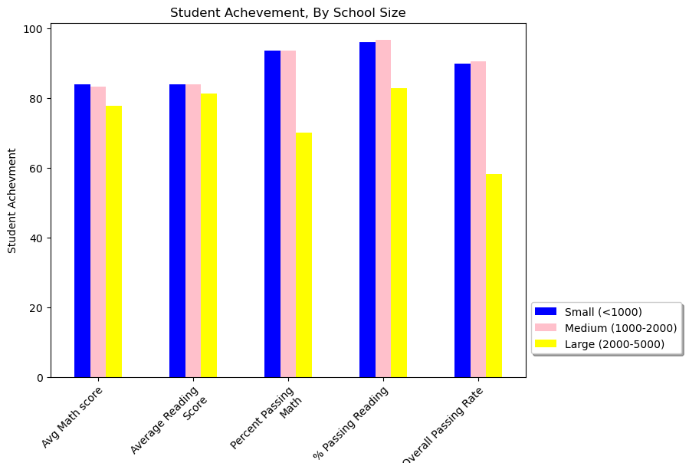

# Scores By School Type

Below is the breakdown of student performance by district or charter school. There are higher scores for math in charter schools (83% vs 80%), reading (83% vs 81%). The percentages of students passing are higher in the charter schools (Math 93.6% vs 66.5%, reading 96.6% vs 80.8%, and overall, 90% vs 53.7%). The bar graph below shows the difference clearly.

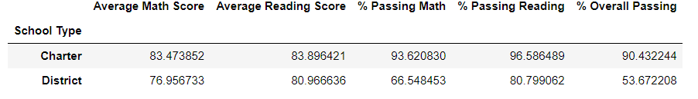

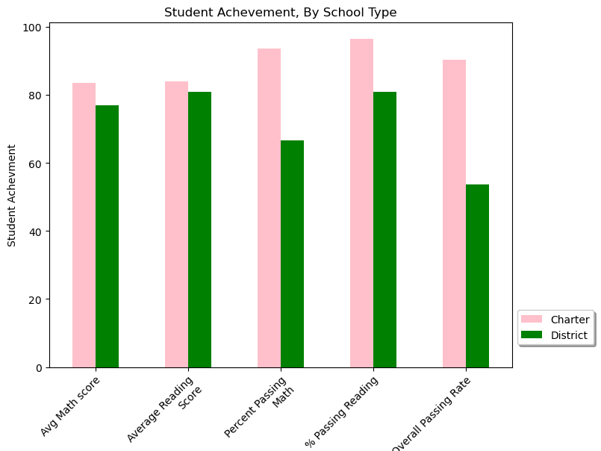

Conclusion

The district has schools that have differences in several areas. The most important differences seem to be found in if the school was a charter school or not (with higher overall student passing rates as well are higher individual, math and reading scores). Thew other important difference between schools in the district is in the amount of money spent per student. There needs to be further analysis to determine why the schools with lower per student spending had better results in math education (measured by percentage of students passing) and in overall student passing rate. There also seems to be some effect in the size of the school. This may be because smaller schools have an easier time helping struggling students.